1. Use Kirchoff’s Current and Voltage Laws to determine all unknown currents and voltages in the following circuit. Show your work in the space beside the diagram.

a) I4 = _______ I5 = _______ V3 = __________ V4 = ____________ V5 = _________

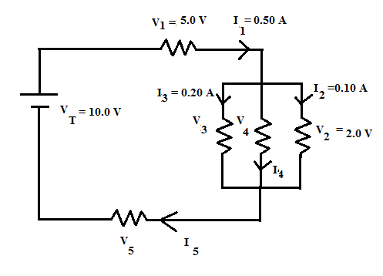

1. Consider the circuit shown below:

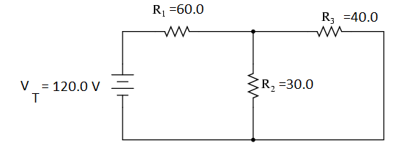

a) Solve for the total equivalent resistance in the circuit:

b) Find the total current flowing from the battery.

c) Find the voltage across each resistor and the current through each resistor.

c) Find the electrical power converted by resistor 1.